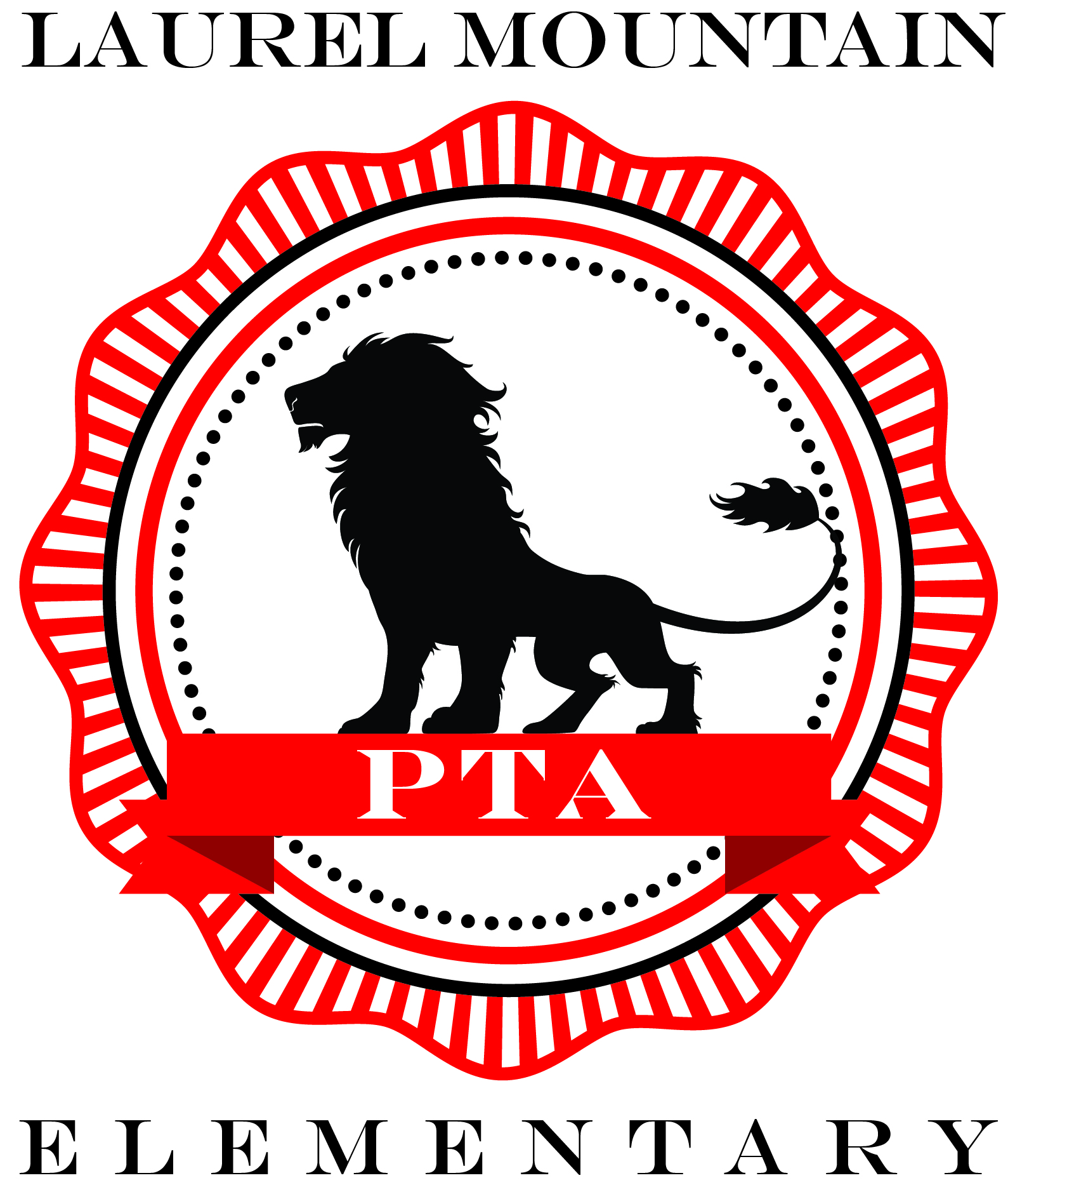
PTA Sponsorship Form
Please note: We have a Sponsor Page on our PTA website at
www.lme.my-pta.org (click on “Sponsors” in the main menu)
You may register your sponsorship there.
Or, complete this form and email
to vickiwalker4@hotmail.com if preferred.

Business

Your Name / Contact Person

Mailing Address

Phone Number

I would like to become a PTA Sponsor (full year sponsorship benefits)
Diamond Lion $1,500.00+ Platinum Lion $1,000.00+
Amount: Amount:

Gold Lion $500.00+ Silver Lion $250.00+
Amount: Amount:

I would like to make a donation of goods and services towards the annual Fall Carnival held on November 4, 2017 or for the Member Appreciation Committee that hosts regular appreciation events for Laurel Mountain teachers and staff.

_________________________________________Value of donated item or service _________________

Make Checks payable to:
Laurel Mountain Elementary PTA

Thank you for supporting Laurel Mountain Elementary! Tax Exempt ID # 74-2377902

